Firebrand flux

186 m

0 m

320 m

FBP X

FBP Y

FBP Z

FCS X

FCS Y

FCS Z

Fire line

Road

320 m

160 m

300 m

250 m

150 m

100 m

50 m

|  |  |  |  |  |  |  |  |  |
| --- | --- | --- | --- | --- | --- | --- | --- | --- |
|  | Firebrands density (pcs/m2) | | | | Flux (pcs/m2.s) | | | |
|  | **500 mm** | **750 mm** | **1000 mm** | **Experiment** | **500 mm** | **750 mm** | **1000 mm** | **Experiment** |
| FCS X | 32.88 | 16.06 | 13.81 | 335 | 0.084 | 0.041 | 0.035 | 0.824 |
| FCS Y | 256.72 | 181.45 | 321.75 | 463 | 0.500 | 0.354 | 0.627 | 0.902 |
| FCS Z | 299.03 | 421.45 | 382.57 | 536 | 0.735 | 1.036 | 0.990 | 1.361 |

|  |  |
| --- | --- |
|  |  |

Suggestions for improvements:

* + Decrease the initial velocity of firebrands.
  + Increase the input rate of firebrands (currently 8000 pcs/s input from all types of firebrands)
  + Fireline location (current location was chosen according to the average location based on fire spreading rate, first and last firebrands’ arrival time)

MATLAB firebrand image processing (Alex Filkov data)

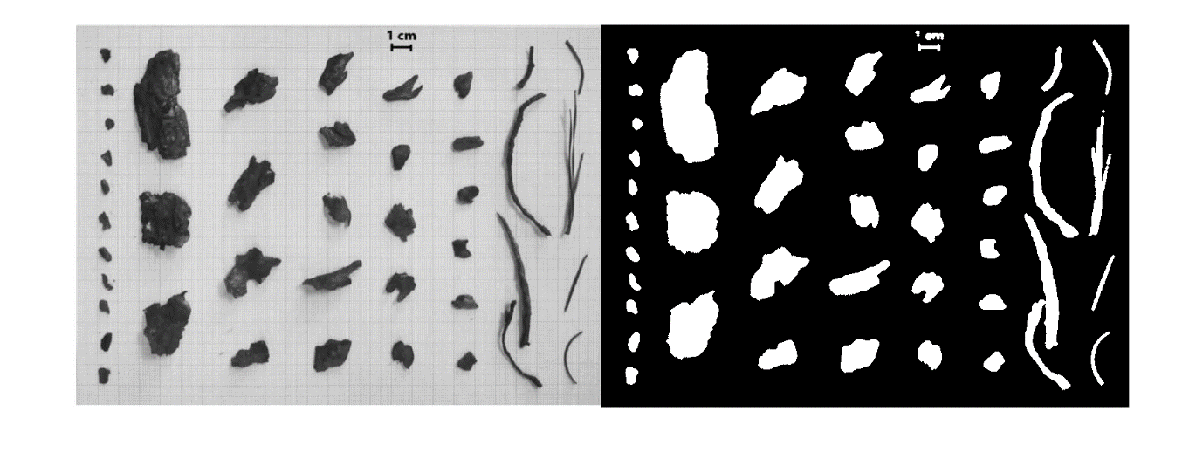

Matlab image processing was measured to find,

* + Centroids
  + Major axis length
  + Minor axis length
  + Eccentricity(e) to find shapes: where e≈ 0, a circle and e ≈ 1, elliptical ---- > cylindrical/cubic

**Hot firebrand experiment (by Tyler et al.)**

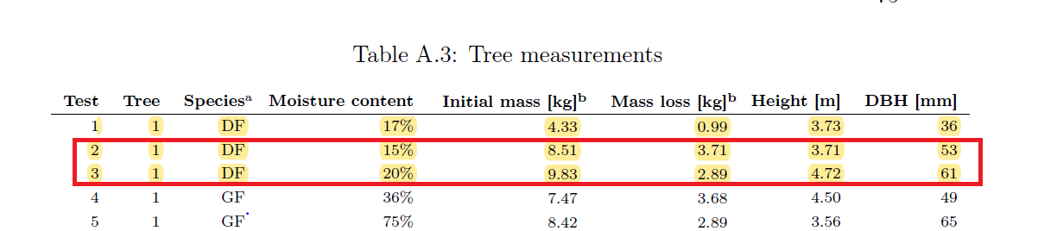

Schematic set up

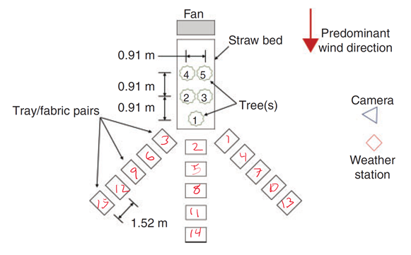

|  |  |
| --- | --- |
| Test 2: DF, MC 15%, H 3.71 m | Test 3:DF, MC 20%, H 4.72 m |
|  |  |
|  |  |

**Expecting to compare above results with Manzello et al.

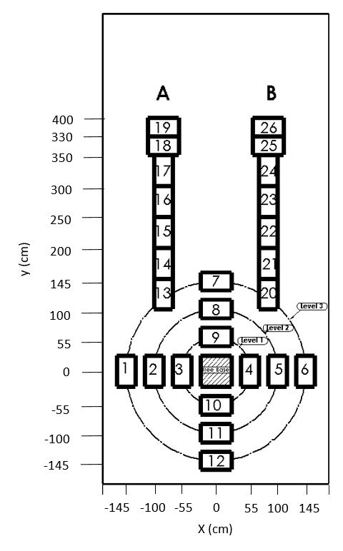

Shapes of the landed firebrands

**expecting to add eccentricity of firebrands of Manzello et al.

**expecting to compare surface area vs mass of firebrands same as the Manzello’s experiment (Fire and Materials 2009).

Douglas fir tree burning Manzello et al: Input number of firebrand vs fire intensity

Total heat release =53 237 KJ

Total mass loss =4.449 kg

Average heat release rate (10 seconds to 34 seconds) = 1602 kW

Number of total input firebrands = 347 pcs

Number of collected firebrands = 70 pcs

Average of input firebrands =10.52 pcs/s (347/33 s)

Input number vs HR = $\frac{average input number of firebrands}{HRR}$

= $\frac{10.52 pcs/s}{1.602 MW}=6.56 pcs/MJ$

Or

Input number vs HR = $\frac{total firebrands input}{total heat released}$

= $\frac{347 pcs}{53.237 MJ}=6.51 pcs/MJ$

In terms of MW- Input number vs HRR;

= $\frac{total input number of firebrands}{average HRR}$

= $\frac{347 pcs}{1.602 MW}=216.6 pcs/MW$

E= Δhc. Δm

|  |  |  |  |  |  |  |  |  |  |
| --- | --- | --- | --- | --- | --- | --- | --- | --- | --- |
| Experiment | Height  (m) | MC  (%) | Initial mass(kg) | Mass loss(kg) | Wind speed(m/s) | Collected firebrands  (pcs) | Input firebrands  (pcs) | Heat released  (kJ) | Input vs HRR (pcs/MW) |
| Manzello | 2.6 | 10 | 10.5 | 4.45 | 0 | 70 | 347 | 53 237 | 217 |
| Tyler T-2 | 3.72 | 15 | 8.51 | 3.71 | 0.59 | 126 | NA | 44 384(calculated) | - |
| Tyler T-3 | 4.72 | 20 | 9.83 | 2.89 | 0.59 | 758 | NA | 34 574 (calculated) | - |